1. **Terrace Garden**  
   The design typically includes landscaped planting areas with ornamental or edible plants, seating zones, and an infinity pool that creates a visual effect of water extending to the horizon. This type of project focuses on maximizing space, enhancing urban living, and providing a serene escape, while also considering structural load, waterproofing, drainage, and sustainable practices.

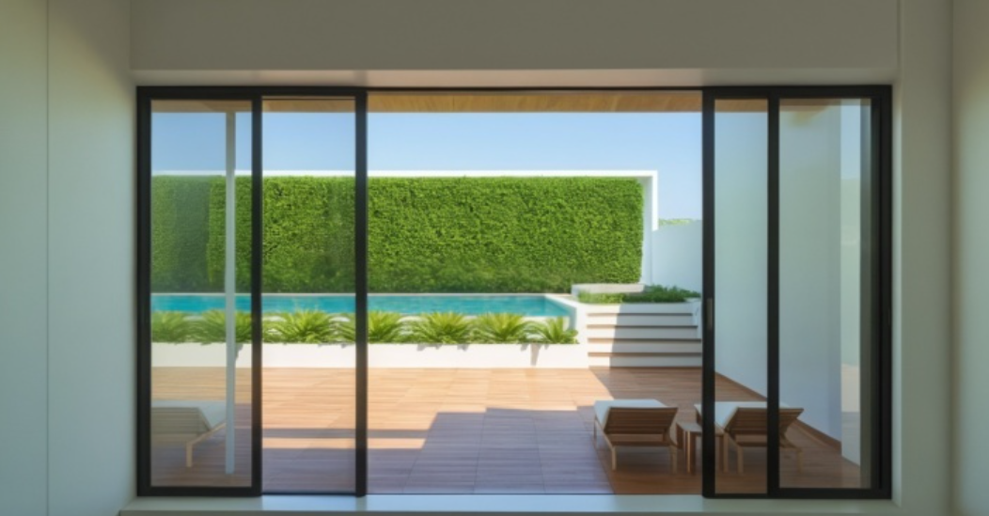

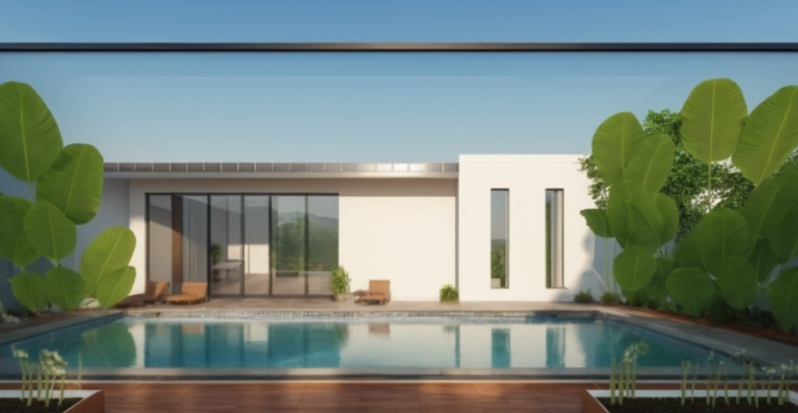

1. **MVJ College Office:**

The design aims to seamlessly integrate the built structures with the rural landscape by using natural materials, native vegetation, and open, flowing layouts that preserve rustic charm and promote sustainable living.

1. **High Rise Apartment:**

The project focuses on efficient vertical space utilization, structural integrity, accessibility, and integration of modern amenities such as elevators, parking, security, and communal areas. Sustainability, fire safety, and compliance with local building codes are key considerations in the planning and execution stages.

1. **Girish’s Backyard:**

The landscape farmhouse project involves designing the outdoor spaces around a farmhouse to enhance its functionality, aesthetic appeal, and connection to nature. The design emphasizes a harmonious blend between the built environment and the rural landscape, often using natural materials, native plants, and open layouts to maintain the rustic charm and support sustainable living.

1. **Anil’s Farmhouse:**

The landscape farmhouse project involves designing the outdoor spaces around a farmhouse to enhance its functionality, aesthetic appeal, and connection to nature. The design emphasizes a harmonious blend between the built environment and the rural landscape, often using natural materials, native plants, and open layouts to maintain the rustic charm and support sustainable living.